Saint Maurice .
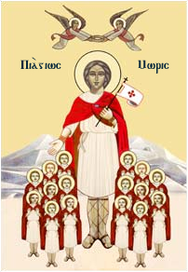

Born:
Died: 287
Canonized: Pre- Congregation
Feast: 22 September
Patronage: Aalpine troops; Appenzell Innerrhoden;^{[1]} armies; armorers; Burgundians; Carolingian dynasty;^{[1]} Austria; clothmakers;^{[2]} cramps; dyers; gout; House of Savoy;^{[1]} infantrymen; Lombards; Merovingian dynasty;^{[1]} Piedmont, Italy; Pontifical Swiss Guards; Saint-Maurice, Switzerland; St. Moritz;^{[1]} Sardinia; soldiers; salt miners; Bad Sulza, Germany; swordsmiths; weavers; Holy Roman Emperors
History of Relic:
Recipient | Date received | Date Returned | Intention
Joseph Samo

